**Test Paper 2**

**Name – Rohit Agarwal**

**TR3**

1. **What is suid, sgid & sticky bit permissions. Explain in brief.**

**Ans.**

* suid – is a special permission where when a command is executed, the process owner will not be the user but the owner of the executable file of that command
  + for example – the owner of the executable file of useradd is root, so it will be executed by the permission of the user
* sgid – is a special permission for the directories, where when a new file Is created inside the directory, its default group owner will become the group owner of the said directory
* sticky bit – is a special permission which doesn’t let the other user delete a creatain file while still having the full permission

1. **( A ) The permission drwxr-sr-- represented in numeric expression will be.**

**( B ) What is the difference between t and T when applying the sticky bit Permission?**

**Ans.**

**( A ) – the numeric value for the permission “drwxr-sr--” is “4754”**

**4 – sgid**

**7 – read, write and execute = for us**

**5 – read and execute = for group**

**4 – read = for others**

**( B ) – The Different Between t and T is**

**t – is sticky bit for others with execute permission**

**T – is sticky bit for others without the execute permission**

1. **( A ) Create a directory called /tmp/techno.**

**( B ) Change the group ownership of the /tmp/techno directory to the technical. Group.**

**( C ) Set permissions on the /tmp/techno directory. On the /tmp/techno directory, configure setgid , read/write/execute permissions for the owner/user and group, and no permissions for other users.**

**Ans.**

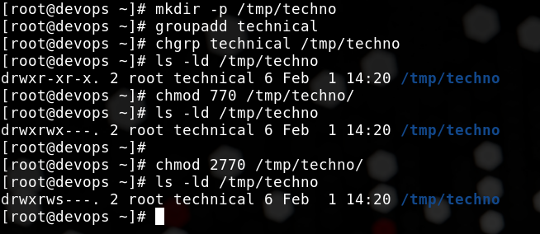

**Changes the group of /tmp/techno to technical and also added permission of sgid and read,write and execute for both user and the group with no permission for others**

1. **A user reports that they cannot delete a file in /tmp even though they have write permission. What could be the reason?**

**Ans.**

**They may not be able to delete a file in the /tmp directory because the parent file may not have give the permission to the user to execute in the directory.**

**For example –**

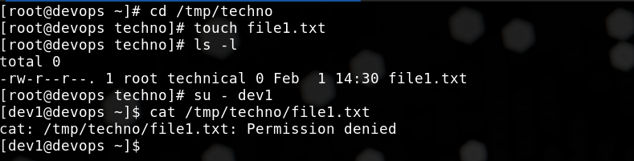

**Even though the file1.txt has permission to read for others, the user dev1 is not able to do so as he doesn’t have permission in the parent directory**

1. **How would you allow a user to have read and execute permissions on a file but not modify it, without changing the group ownership?**

**Ans.**

**To give user permission of read and execute on a file without changing the group ownership is by using ACL – Access control list**

**For Example –**

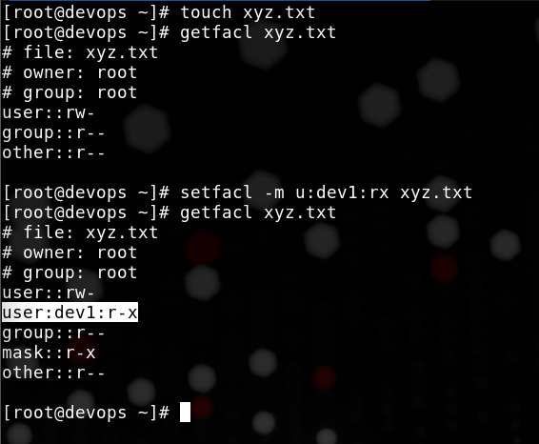

**We can set the permission of read and execute on the file by using acl**

1. **You are required to configure the AlmaLinux 9 repository on your system using the following repository URLs:**

**• AppStream:** [**https://repo.almalinux.org/almalinux/9/AppStream/x86_64/os**](https://repo.almalinux.org/almalinux/9/AppStream/x86_64/os)

**• BaseOS:** [**https://repo.almalinux.org/almalinux/9/BaseOS/x86_64/os**](https://repo.almalinux.org/almalinux/9/BaseOS/x86_64/os)

**Before configuring the new repositories, ensure that all existing repositories are removed from the system.**

**Tasks: 1. Remove all existing repositories from the system.**

**2. Create new repository configuration files for AlmaLinux 9 AppStream and BaseOS.**

**3. Verify that the new repositories are properly configured and working.**

**Ans.**

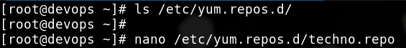

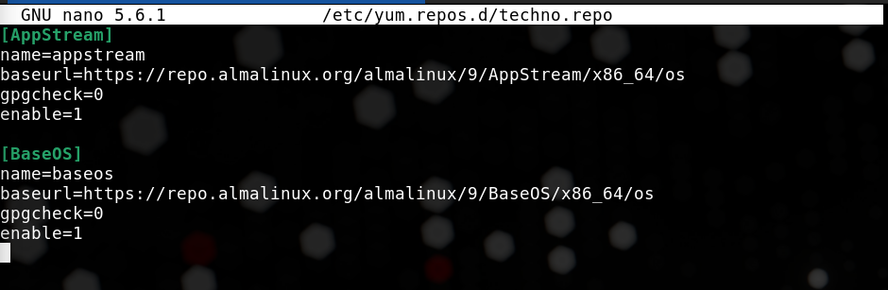

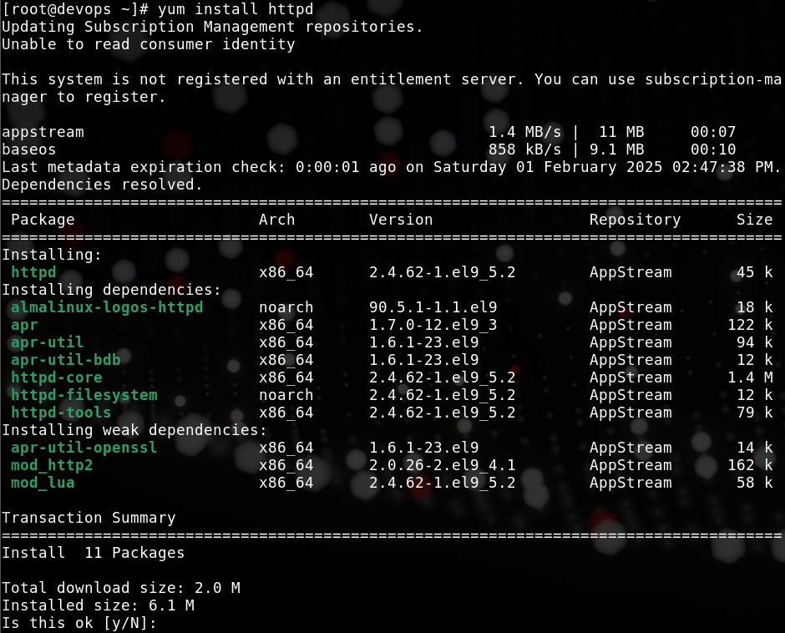

1. **( A ) Which command lists all installed RPM packages on the system?**

**( B ) Which command identifies the package that a /etc/passwd file belongs to?**

**( C ) Which command lists all files installed by a coreutils package?**

**Ans.**

1. **Rpm -qa**

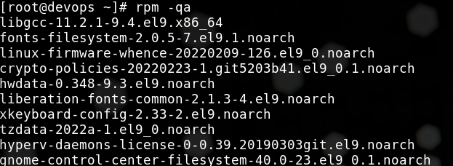

1. **Rpm -qf /etc/passwd**

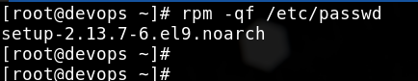

1. **rpm -ql setup-2.13.7-6.el9.noarch**

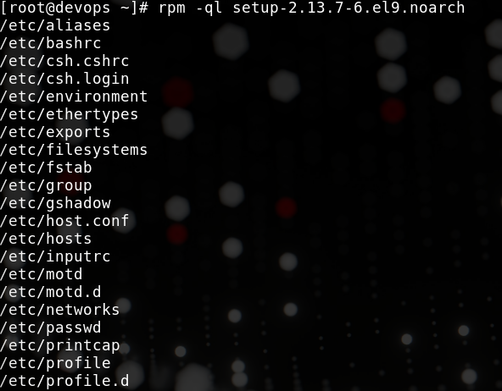

1. **( A ) Install httpd packages using yum.**

**( B ) Start & Enable it’s service. ( httpd.service )**

**Ans. yum install httpd**



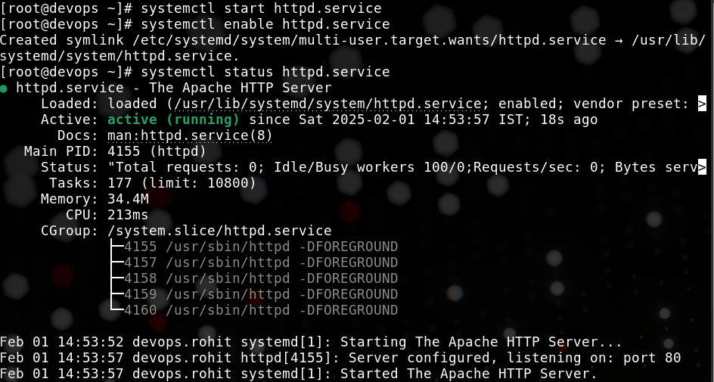

1. **What is the difference between dnf, yum, and rpm package management tools in RHEL- based systems?**

**Ans.**

**Rpm – is used to install, delete and update any package but can only do for the .rpm files present in the system and cannot resolve dependences**

**Yum – is a package manager which is used to install, update and remove any package from the system and can also resolve dependencies**

**Dnf – is a advance version of the yum. Has extra features than yum**

1. **( A ) How to list all enabled service on your machine.**

**( B ) How mask firewalld.service.**

**Ans.**

1. **- systemctl list-unit-files | grep "enabled"**

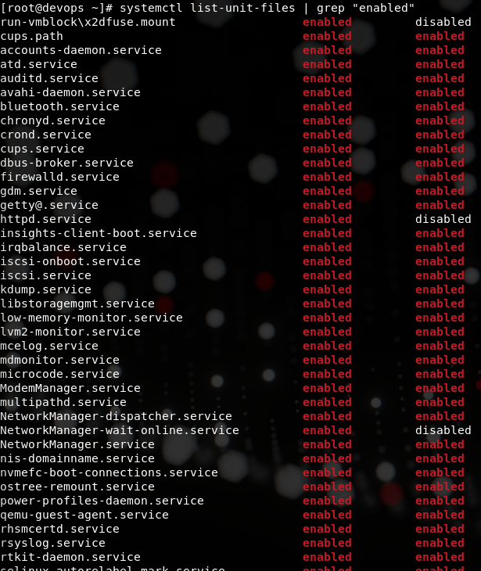

**Mask the firewalld.service**

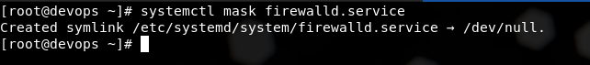

1. **( A ) How to display load average.**

**( B ) How to filter out processes by CPU utilization.**

**Ans.**

1. **Uptime**



1. **ps -eo %c**

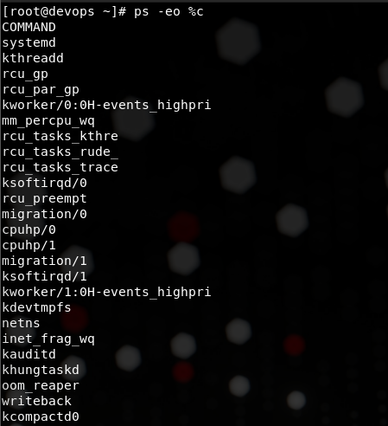

1. **Define various process states in os.**

**Ans.**

**There are many type of process in linux**

1. **User Process**
2. **System Process**
3. **Deameon Process**

**The varios state the process are in**

* **Killable State**
* **Ready State**
* **Running State**
* **Waiting State**

1. **( A ) What is the default signal to terminate a process.**

**( B ) What is the signal to continue a process.**

**Ans.**

1. **- The default signal is 15 – SIGTERM which gracefully terminates the process**
2. **- The signal to continue a process is**
3. **( A ) How to get back jobs from background to foreground .**

**( B ) How to change priority of a running process**

**Ans.**

1. **– we can use the fg command with the job id to bring job from the background to the foreground**
2. **( A ) What is zombie process.**

**( B ) How to kill all process running by a particular user .**

**( C ) How to kill all process running in a particular terminal .**

**Ans.**

1. **A zombie process is a process which is supposed to be completed but is still present in the process table.**

**We can find the zombile process by “ ps aux | grep “zombie”**

1. **We can kill all the process of a particular user by using the pkill command**

**Pkill -u <user>**

1. **We can kill all the process of a particular terminal by using the pkill command**

**Pkill -t pts/1**